ContainerHomes.Net  San Ramon de Alajuela  Costa Rica  WhatsApp:  USA 512-650-0231 | 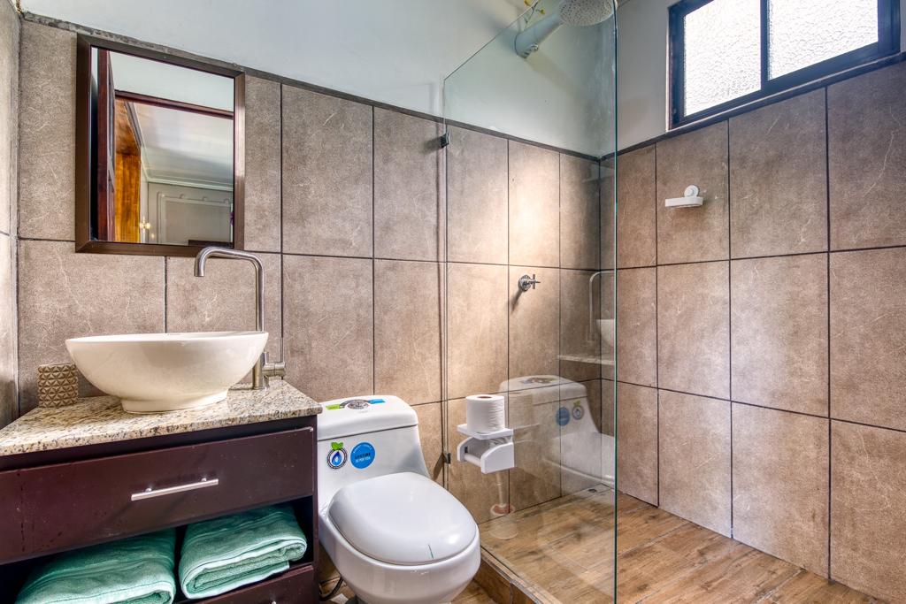
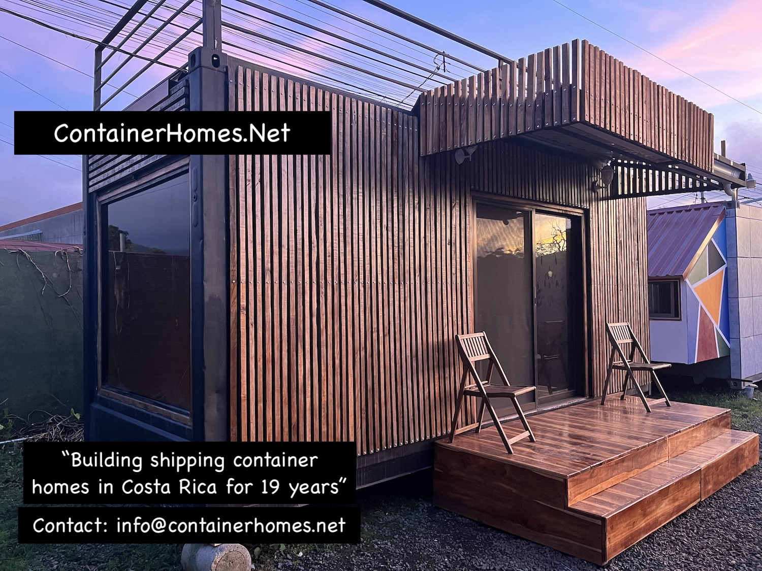 | 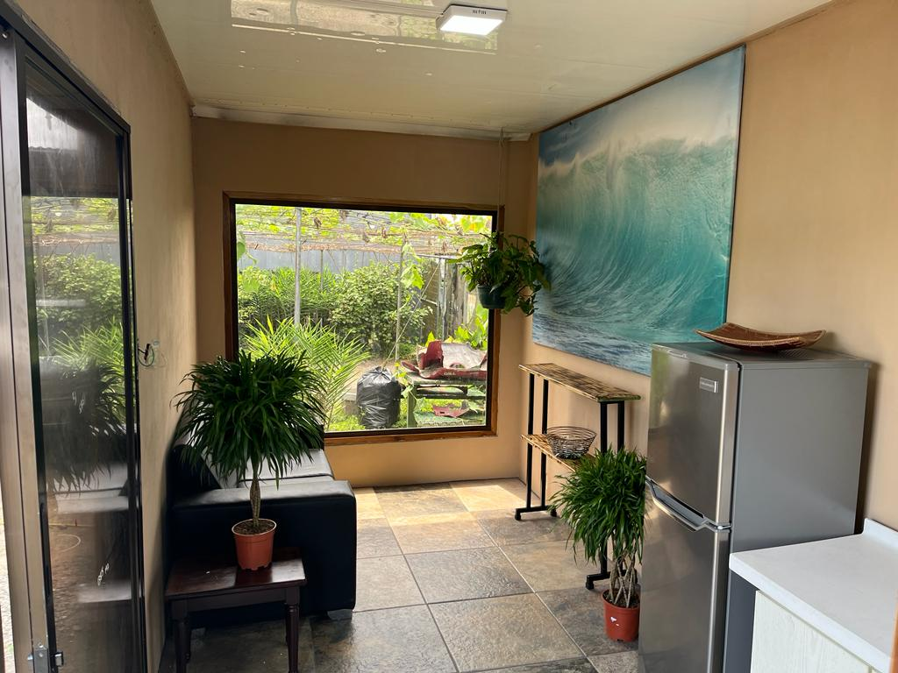
ContainerHomes.net – San Ramón de Alajuela, Costa Rica
18 Years of Building Quality Shipping Container Homes
Quick Facts
• Sizes Available:
- 20 ft and 40 ft lengths (8 ft 6" wide)
- High Cube refrigerated models: 9 ft 6" tall
• Build Time: 8–10 weeks
• Waitlist: Apply 6–12 months before desired delivery date.
Site Preparation & Installation
We can provide full quotes for:
- Site preparation
- Septic systems
- Foundations
- Installation and utility connections (electric, water, sewage)
Additional Construction Options
- Roofs and decks to match your design
- Rooftop decks and stair access available

Transportation & Crane Service
We provide our own transportation and crane equipment:
- Required for loading/unloading onto foundations
- Typical cost: $1,200–$3,000 (varies by location)
Permit Guidance
- Requirements vary by region.
- Most single units outside city limits do not require permits.
- We can guide you through the process if needed.
Inspection Service (Recommended)
- Cost is based on travel distance (typically $250–$350).
- Includes a full property access inspection: roads, bridges, low-hanging cables, low tree branches, sharp turns, soft soil conditions, and overall site accessibility.
- During the visit, we can also provide a foundation and septic system quote.
- This inspection helps prevent delivery issues and ensures a smooth transport and installation process. Once approved, transport and installation access for the tractor-trailer becomes our responsibility.
The inspection is conducted by our project manager, who is also a professional truck and crane operator with extensive experience.
This step is strongly recommended for all home construction projects, especially when transporting and installing units with glass and ceramic finishes.
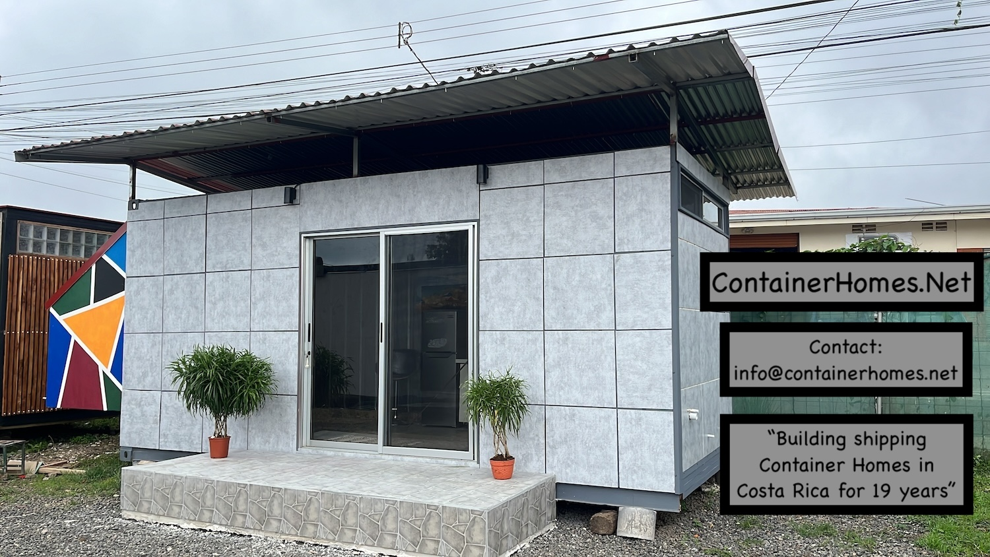

Home Description
Each turn-key container home includes:
- Full electrical & water installation (kitchen & bathroom)
- Finished bathroom: ceramic tile, sink, and shower
- Kitchen: plumbing, electric, and window (no cabinets)
- Insulation: stainless steel walls + 3” spray-foam
- Flooring: full ceramic tile (client’s choice)
- Painting: interior white, exterior color chosen by client
- Doors & Windows: 1 sliding glass door, 1 bath window, 1 kitchen window, 1 per bedroom (40 ft models)

Prices start at…….
Building with Refrigerated shipping containers:
- 20ft Finished Turn-Key Home: $20,000
- 25ft Finished Turn-Key Home: $25,000
- 40ft Finished Turn-Key Home: $34,700
- 20ft Turn-Key Home, Roof top deck, stairs, Teak wood exterior: $25,000
- 40ft Turn-Key Duplex Apartment: $38,000

Used Shipping Container Prices:

40ft shipping containers: $3800
40ft HQ shipping container: $4400
40t HQ Refrigerated container: $4500
20ft Container: $3600
20ft Reefer container: $4100

Prices do not include:
Transportation, Crane Rental, Installation, Site preparation, Permits.
Extras: Internal walls covered with cement board throughout. Steel security bars, Roof Top Decks, Additional Windows, Ceiling Fans, Air Condition.

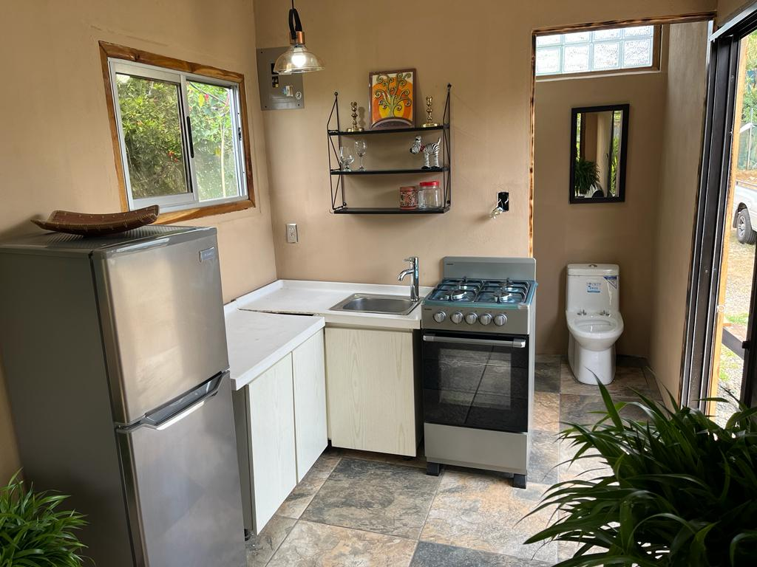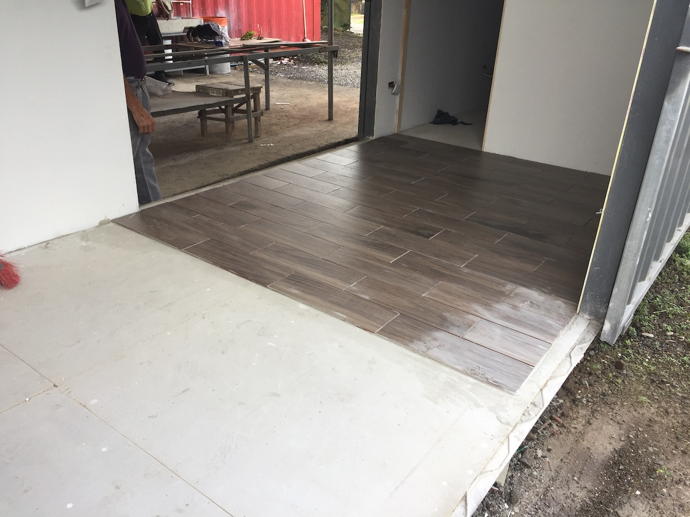

Transportation and Installation
The transportation of the finished home will require a truck with a crane handle. This is important for the home to be delivered and installed on its foundation without damaging to the ceramic tile and glass. The 40ft truck with the crane hand is priced between $1200-$2500, depending on the distance to the property. The client must ensure us that the roads suitable for the transport and that there are no sharp turns, bad roads, low lying cables and/or branches.
There is a $275 road inspection fee prior to transport to assure a safe delivery.
______________________________________
The installation of the container homes requires a connection for the water, septic and electric. We can help the client with this process; however, you will need to have your own local crew on the ground to assist us. Also, the client is responsible for all the materials to connect these. The water needs additional PVC tubes. The septic needs large PVC tubes, and the electric requires costly cable, the distance from the street to the home. The property needs to have electric from ICE and the water from AYA already installed on the property.

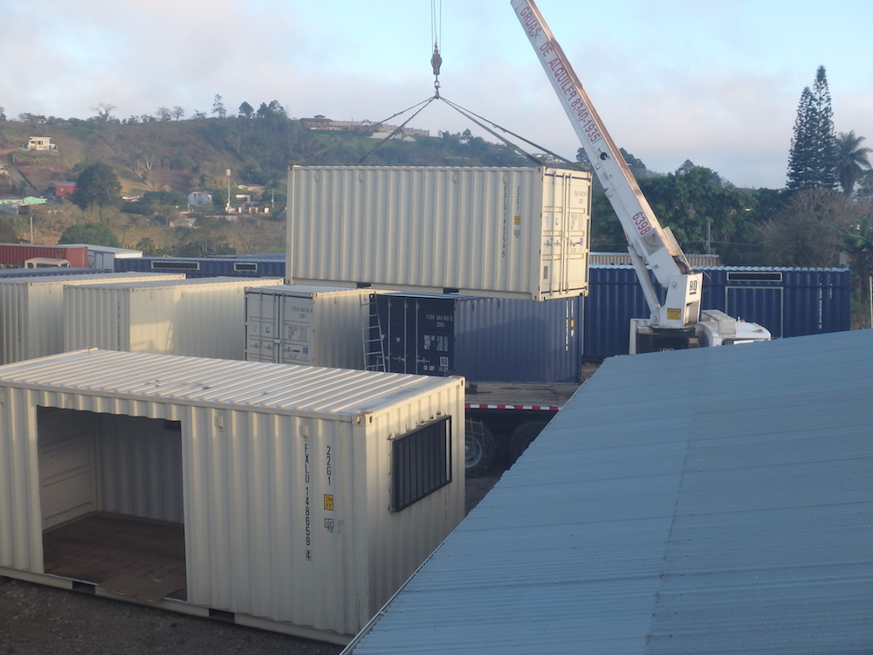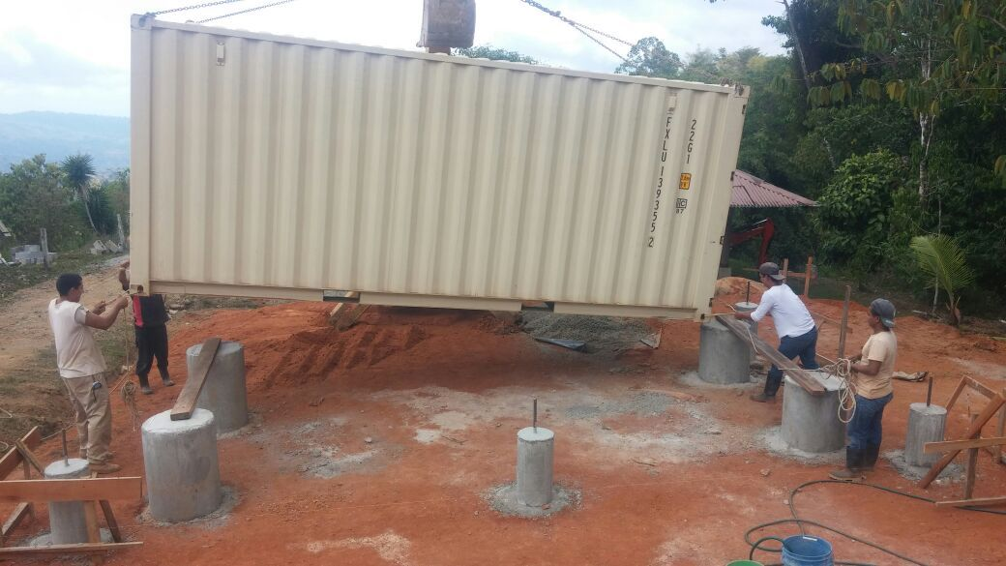

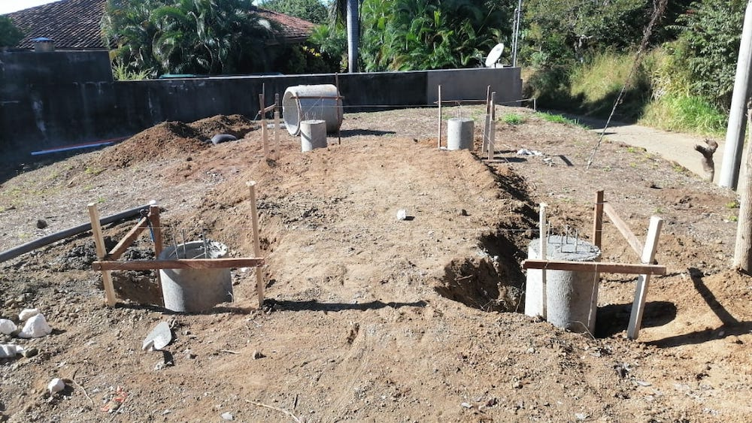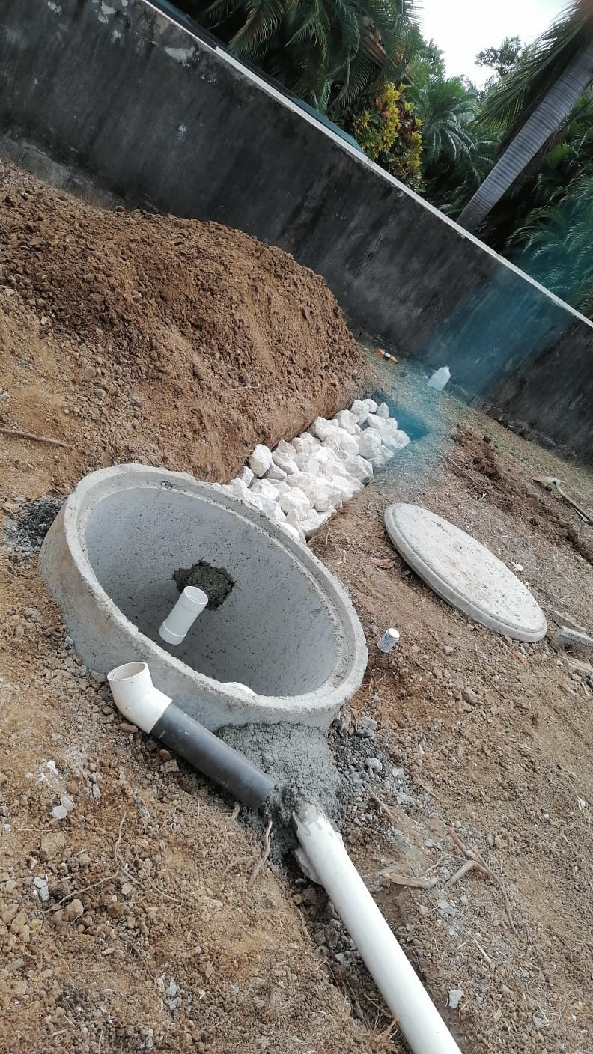

Site Prep and Septic
The site prep and septic are an additional service our company provides. We need to drive out to your property for the inspection and estimate. The price range for septic and foundation start at $3500. The client needs to have the land cleared and level before we begin. The types of foundations depend on the client. Some people want the container to sit high up off the ground and have crawl space below. Others want the container to be directly on the ground, so they do not need to use steps and build a deck. The containers are safe to sit directly on the ground however it is recommended to have a cement platform underneath the home.

Here are two examples of Roof Top decks for Container Homes:
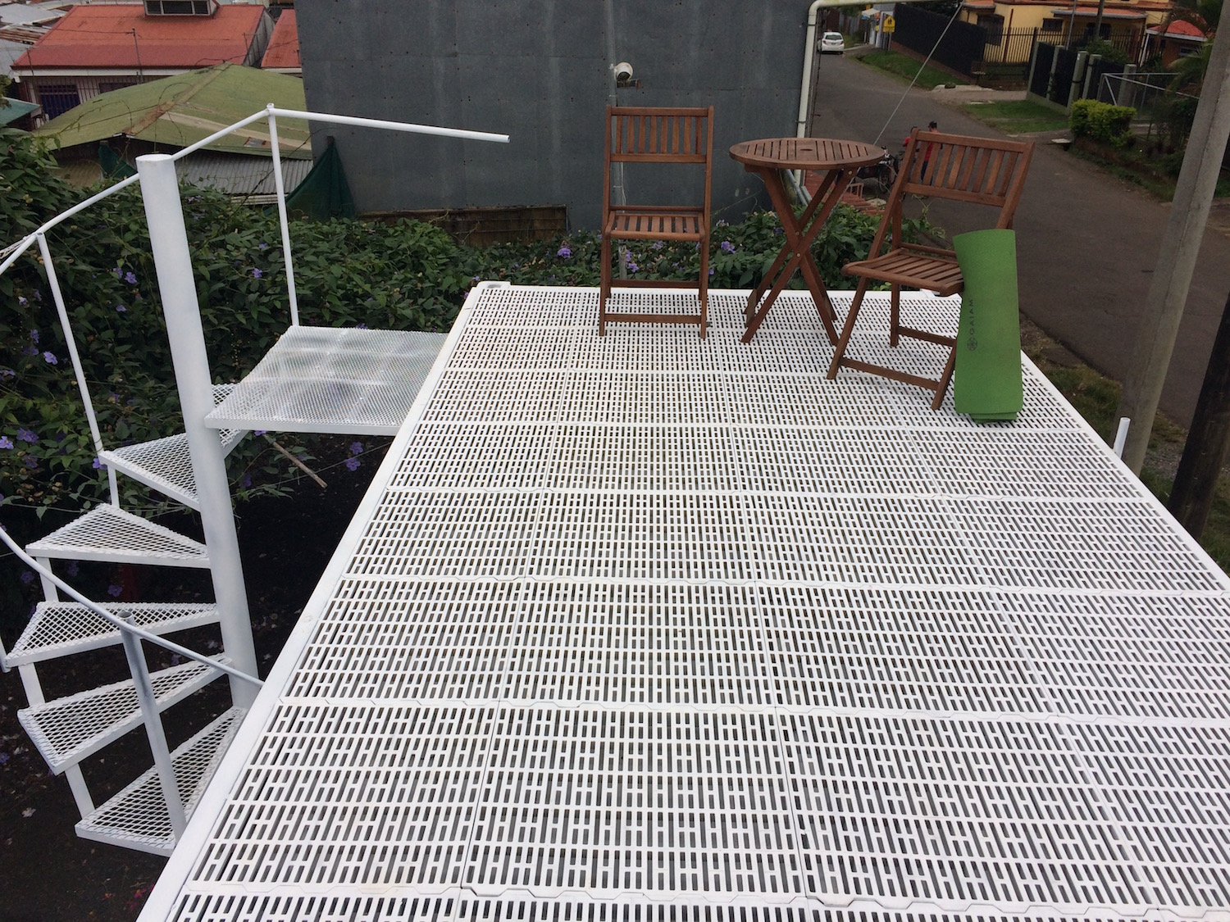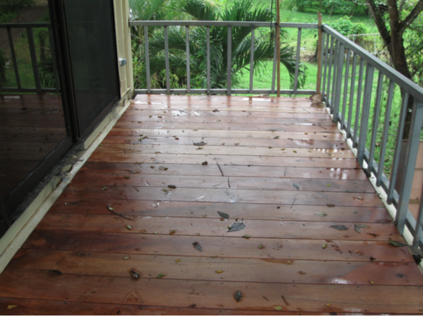

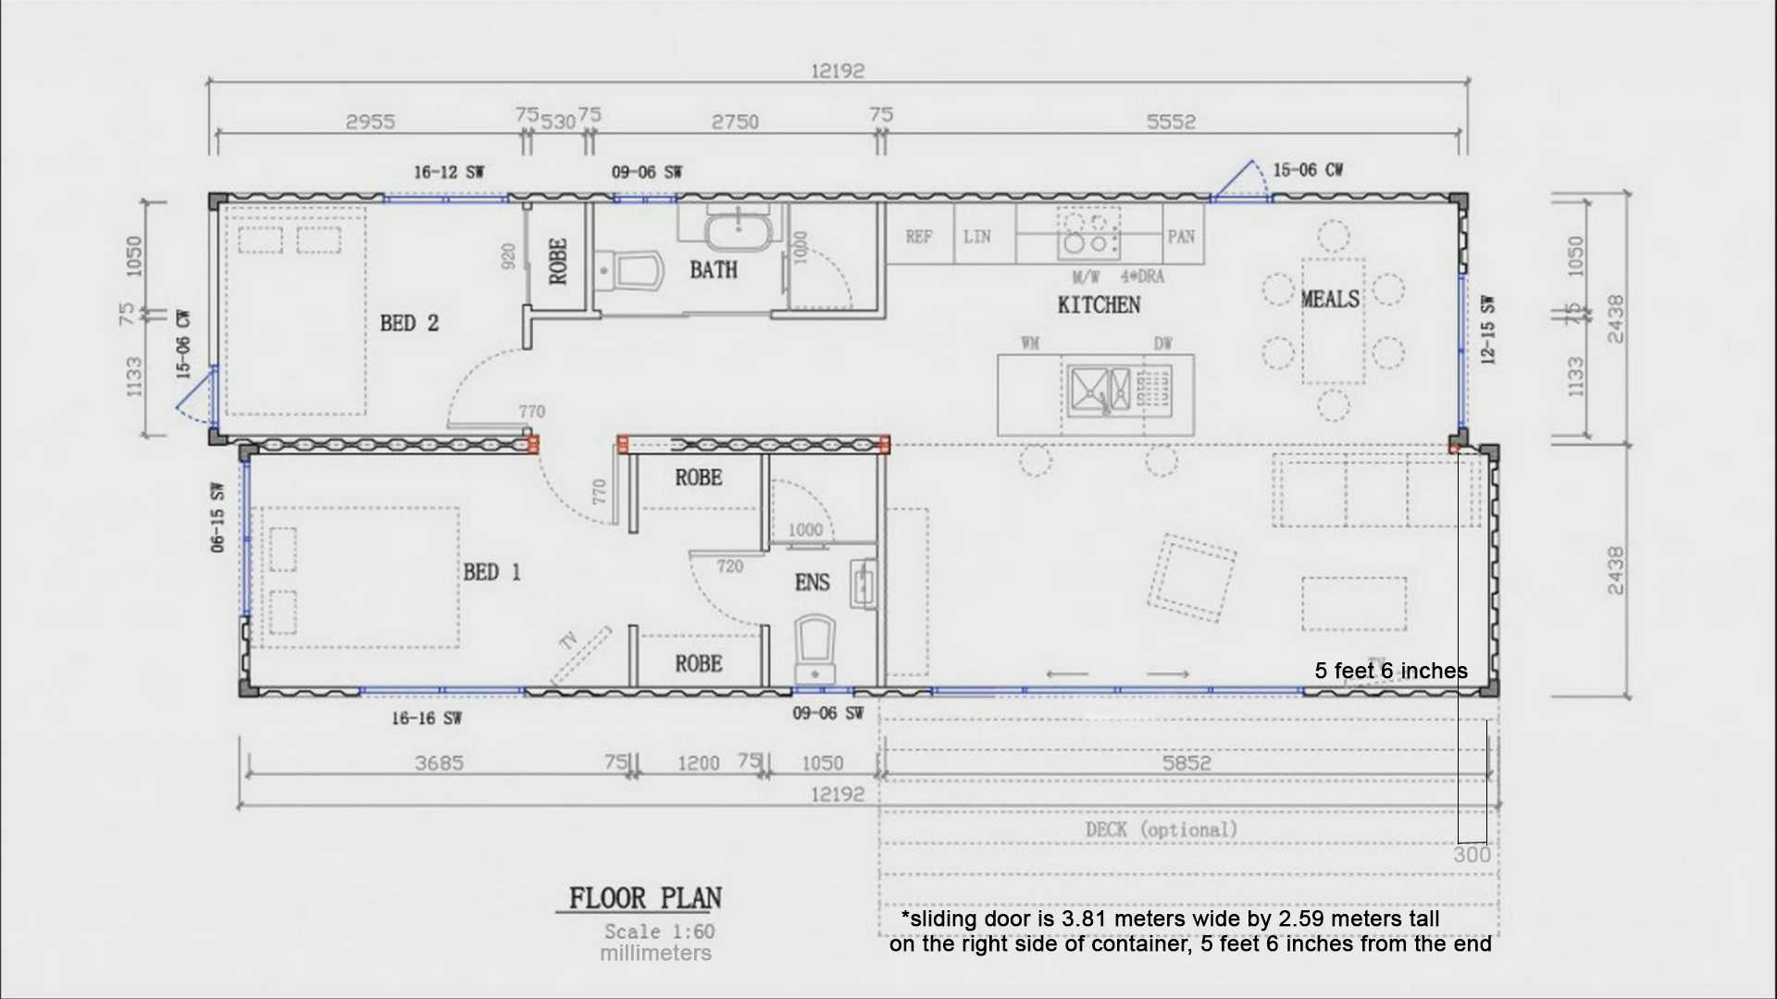

Sizes and design
We have several different options for the 40ft homes and limited design options for the 20ft home. This we can discuss and send samples. We also can merge two or more containers together both side by side or in a stacking design. We do not build roofs, decks, or anything additional besides the actual container home. We do build roof top decks on top of the container as well as spiral staircases. Many past clients did not attain permits for their home. These were mostly single units, located on their land outside a city. The permit process is the client’s decision, most permits range in pricing depending on the architect and service you enroll. We have seen these permits range from $900-$3000 for a single unit. We can aid with this process, but we do not do it alone. The client must be part of this process. Below we have the external and internal measurements for the 20ft and 40ft Refrigerated shipping Containers.
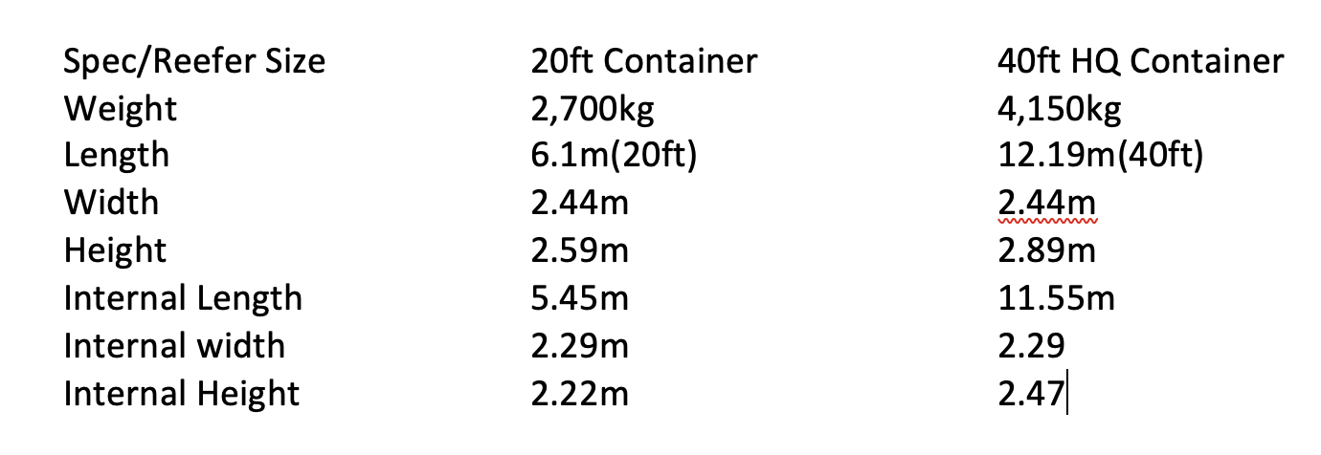

________________________________________________________Sample Contract:
- TWO 40ft x 8ft x 9.6 ft Used refrigerated shipping container. VIN#_______________ VIN#_________________
- Complete Electrical system throughout the home, including light switches and outlets in accordance with the final layout and design, for both container homes.
- One breaker box with 110V set-up per container home.
- Electrical set up for multiple AC units.
- Electrical set up for external lights.
- FOUR Ceiling fans located in accordance with the final layout and design.
- Ceramic floor throughout both homes.
- One 2-meter glass sliding door per bedroom. Three in total.
- Kitchen ceramic counter “L-shape” in accordance with the final layout and design. Kitchen includes multiple above counter electric outlets and floor outlets. Above lighting, sink, faucet and all the required plumbing.
- Finished Bathrooms, including one light, shower (34”x 62”), sink, faucet, toilet, ceramic floor. THREE full bathrooms, ONE half bathroom. The Half bathroom design will have a 220V for washer and dryer.
- One small window per bathroom, location over toilet.
- One window in the living room/Kitchen area. (1mx 7.m) * over the sink area.
- One window in the bedroom/living room area. (4ft length x 3 ft height)
- All plumbing set up for hot water. *Not including water heater.
- Exterior of the container painted with an anti-corrosive paint. Client chooses. for both containers.
- This quote is based on standard windows, not double pain insulated windows.
- All window and glass doors include screens.
- Not including AC units.
Not Included in the price quote:
- Transportation and crane costs to destination.
- Appliances.
- Hot water tanks
- Installation.
- Permits.
Special Notations: 1. The containers can be stored up to 12 mths from the date of the contract with no additional fees. 2.Upon payment the “buyer” becomes the owner of the container and can retrieve the container under any “unusually” situations, for example, default on production of the home, bankruptcy, criminal charges, death or absence of owner, etc.
BILL OF SALE KNOW ALL PERSONS BY THESE PRESENTS:
James J. Lee, USA Citizen, bear of Passport #_________ acting as representative with Full Power of Attorney of the company: Container Emergency Shelter Home LMTD, Persona Juridica: ___________, hereinafter identified as the "AGENT"; have agreed to enter into the present "BUYER'S CONTRACT", which shall be governed by the Laws of the Republic of Costa Rica and by the following clauses: FIRST: The AGENT as a Container Homes Brokerage Firm will provide the client with the authorized tag numbers on the shipping container in question. The shipping container will have the dimensions enclosed, and a general state of condition. I, the undersigned seller, hereby certify that the items for sale as stated in this contract are in working condition and structurally sound. I, the undersigned seller, certify that said TWO “ 40ft x 8ft x 9.6ft” Modified Refrigerated Shipping Containers”, are owned and sold by me and I warrant them to be free of any liens, claims, security agreements, encumbrances, charges and demands. I, the undersigned buyer, acknowledge receipt of this Bill of Sale and understand that the above-described items are sold in “as is” condition and there is no other expressed or implied warranty or guarantee. I, the undersigned BUYER, acknowledge that I am responsible for the transport of the container to its final destination. That the roads are suitable for the transport and that the driver needs to install the container as close as possible to its final destination as the road seems fit. Even if this is not at the final destination. The driver makes the final decision on road and personal safety. The driver holds the right to refuse the delivery if the client has been misleading in the directions and conditions of both road and land. The BUYER will be responsible for FEES associated with cutting branching or waiting on ICE to come lift low hanging wires, as well as any additional crane and/or backhoe rental fees if the road and or property is impassable. The BUYER will pay for any additional time required for the driver due to unpassable conditions.
We (buyer and seller) certify that all of the above information provided in this document is true and accurate to the best of our knowledge.

